SOCShield
Intelligent Web Attack Detection,
Threat Intelligence, and Automated Incident
Response Platform.
Technical Project Documentation
A Security Operations Center (SOC) platform for
real-time web attack detection, threat intelligence
enrichment, and automated incident response.
Version: 1.0
Author:
Om Dhumal
Technologies:
Wazuh SIEM | ModSecurity WAF | NGINX | DVWA
Burp Suite | VirusTotal | MITRE ATT&CK
Postfix | Linux
Date: May 2026
- Table of Contents:
- Introduction
- Problem Statement
- Objectives
- Tools and Technologies
- Solution Architecture
- Implementation
- Attack Simulation
- MITRE ATT&CK Mapping
- Active Response
- Threat Intelligence Integration
- Email Alerting
- Dashboard & Monitoring
- Results
- Challenges Encountered
- Future Enhnacements
- Conclusion

Executive Summary
Organizations increasingly face sophisticated cyber threats targeting web applications, including Cross-Site Scripting (XSS), SQL Injection (SQLi), and Remote Code Execution (RCE) attacks. Traditional monitoring approaches often lack centralized visibility, threat intelligence enrichment and automated response capabilities, making timely detection and mitigation difficult.
SOCShield is an intelligent Security Operations Center (SOC) platform designed to provide real-time web attack detection, threat intelligence integration, and automated incident response. The platform combines multiple open-source security technologies, including Wazuh SIEM, ModSecurity Web Application Firewall (WAF), NGINX, DVWA, VirusTotal, MITRE ATT&CK Mapping, Postfix Email Alerting and Linux-based monitoring components.
The solution continuously monitors web application activity, collects and analyzes security logs, identifies malicious behavior, correlates security events, and generates actionable alerts. Attack simulations were performed using Kali Linux and Burp Suite to validate the detection of Cross-Site Scripting (XSS), SQL Injection (SQLi), and Remote Code Execution (RCE) attacks. Detected events are mapped to relevant MITRE ATT&CK techniques to improve threat visibility and investigation capabilities.

To enhance incident response, SOCShield integrates automated firewall-based active response mechanisms capable of blocking malicious source IP addresses. The platform also incorporates VirusTotal threat intelligence enrichment and real-time email alerting to improve analyst awareness and response efficiency.

A centralized dashboard provides security monitoring, threat hunting, attack visualization, MITRE ATT&CK mapping, attacker IP analysis, alert severity monitoring, and incident investigation capabilities. The implementation demonstrates how open-source security technologies can be integrated to build a practical and cost-effective SOC environment for web application security monitoring and incident response.

The results confirm the successful detection, analysis, alerting, and response to multiple web-based attack scenarios, making SOCShield a comprehensive platform for modern security operations and threat management.

- Introduction

In today's digital landscape, organizations rely heavily on web applications and online services to support business operations, customer interactions, and data management. While these technologies provide significant advantages, they also introduce a growing attack surface that can be exploited by cybercriminals. Web-based attacks such as Cross-Site Scripting (XSS), SQL Injection (SQLi), and Remote Code Execution (RCE) continue to be among the most common and impactful threats targeting modern applications.

As cyber threats become increasingly sophisticated, organizations require more than traditional security controls. Modern security operations demand continuous monitoring, centralized log analysis, threat intelligence integration, attack correlation, and automated incident response capabilities. Security Operations Centers (SOCs) play a critical role in achieving these objectives by providing visibility into security events and enabling security teams to detect, investigate, and respond to threats in real time.

Security Information and Event Management (SIEM) platforms have become essential components of SOC environments. SIEM solutions collect logs from multiple sources, correlate events, generate alerts, and provide centralized monitoring capabilities. When combined with Web Application Firewalls (WAFs), threat intelligence platforms, and automated response mechanisms, SIEM systems significantly improve an organization's ability to identify and mitigate cyber threats.

SOCShield is designed as an intelligent web attack detection, threat intelligence, and automated incident response platform built using open-source cybersecurity technologies. The platform integrates Wazuh SIEM, ModSecurity Web Application Firewall (WAF), NGINX Web Server, DVWA (Damn Vulnerable Web Application), VirusTotal Threat Intelligence, MITRE ATT&CK Mapping, Postfix Email Alerting, and Linux-based monitoring components into a unified security monitoring environment.

The platform continuously monitors web application activity, collects security logs, detects malicious behavior, enriches alerts with threat intelligence data, maps attacks to the MITRE ATT&CK framework, and performs automated response actions when security incidents are identified. To validate the effectiveness of the platform, multiple attack scenarios including Cross-Site Scripting (XSS), SQL Injection (SQLi), and Remote Code Execution (RCE) were simulated using Kali Linux and Burp Suite.

The primary goal of SOCShield is to demonstrate how open-source security technologies can be integrated to create a practical, scalable, and cost-effective Security Operations Center capable of detecting, analyzing, and responding to modern web-based cyber threats in real time.
- Problem Statement

Modern organizations increasingly depend on web applications to support business operations, customer services, and data management. While web technologies provide flexibility and accessibility, they also introduce significant security risks. Cyber attackers frequently target web applications using techniques such as Cross-Site Scripting (XSS), SQL Injection (SQLi), and Remote Code Execution (RCE) to gain unauthorized access, manipulate data, or disrupt services.

Many organizations rely on traditional security monitoring approaches that generate large volumes of logs but provide limited visibility into actual security threats. Security teams often face challenges in identifying malicious activities across multiple systems, correlating security events, and responding to incidents in a timely manner. In addition, the absence of centralized monitoring, threat intelligence integration, and automated response mechanisms can significantly increase the time required to detect and mitigate attacks.

Web Application Firewalls (WAFs) and logging solutions can generate valuable security data; however, without proper analysis, correlation, and visualization, organizations may struggle to transform raw logs into actionable security insights. Furthermore, many environments lack automated incident response capabilities, resulting in delayed containment of malicious activities and increased security risks.

To address these challenges, there is a need for a unified Security Operations Center (SOC) platform capable of continuously monitoring web application activity, detecting attacks in real time, correlating security events, enriching alerts with threat intelligence, and automatically responding to malicious activities. Such a platform should provide centralized visibility, improve threat detection accuracy, reduce incident response time, and assist security analysts in investigating and managing security incidents effectively.

SOCShield was developed to address these challenges by integrating Security Information and Event Management (SIEM), Web Application Firewall (WAF) monitoring, threat intelligence enrichment, MITRE ATT&CK mapping, automated response mechanisms, and real-time alerting into a single security monitoring platform. The solution aims to enhance an organization's ability to detect, analyze, and respond to modern web-based cyber threats efficiently and effectively.

3. Objectives

The primary objective of SOCShield is to design and implement an intelligent Security Operations Center (SOC) platform capable of detecting, analyzing, and responding to web-based cyber threats in real time. The platform aims to enhance security visibility, improve incident response capabilities, and demonstrate the effective integration of open-source cybersecurity technologies.

The specific objectives of the project are as follows:

1. To develop a centralized security monitoring platform using Wazuh SIEM for collecting, analyzing, and correlating security events.

2. To deploy and configure ModSecurity Web Application Firewall (WAF) with OWASP Core Rule Set (CRS) for detecting and mitigating web application attacks.

3. To simulate real-world web attacks, including Cross-Site Scripting (XSS), SQL Injection (SQLi), and Remote Code Execution (RCE), using Kali Linux and Burp Suite.

4. To create custom detection rules for identifying and classifying web-based attacks within the Wazuh environment.

5. To integrate MITRE ATT&CK Mapping for improved threat visibility and attack classification.

6. To implement Active Response mechanisms capable of automatically blocking malicious source IP addresses through firewall-drop actions.

7. To integrate VirusTotal Threat Intelligence services for alert enrichment and reputation-based threat analysis.

8. To implement real-time email alerting for notifying security analysts about critical security incidents.

9. To develop interactive SOC dashboards for threat hunting, attack visualization, incident monitoring, and security analysis.

10. To demonstrate a practical and cost-effective approach for building a modern Security Operations Center using open-source technologies.

11. To improve the overall capability of detecting, investigating, and responding to web-based cyber threats through centralized monitoring and automated response mechanisms.

4. Tools and Technologies

SOCShield was developed using a combination of open-source cybersecurity, monitoring, web security, and threat intelligence technologies. Each component was selected to provide a specific security function within the overall architecture, enabling attack detection, threat analysis, automated response, and centralized monitoring.

Tool/Technology Category Purpose in Project
Kali Linux Attack Simulation Used to simulate web-based attack
Platform such as Cross-Site Scripting (XSS),
SQL Injection (SQLi), and Remote
Code Execution (RCE).
Burp Suite Web Application Testing Used for intercepting, modifying,
Tool and replaying HTTP requests during
attack simulation.
DVWA (Damn Vulnerable Web Served as the target application for
Vulnerable Web Application security testing and attack
Application) simulation.
Ubuntu Server Operating System Hosted the web application, WAF
SIEM Components, monitoring
Infrastructure.
NGINX Web Server Hosted DVWA and processed
Incoming HTTP requests before
Inspection by ModSecurity.
ModSecurity Web Application Inspected web traffic and detected
Firewall malicious request like XSS, SQLi etc
OWASP Core Rule Security Rules Provided predefined attack detection
Set (CRS Firewall (WAF) rules for common web application
threats.
Wazuh Agent Endpoint Monitoring Collected logs and security events
Component from the monitored server
environment.
Wazuh Manager Security Information Performed log collection, event
and Event Management correlation, rule matching, and
(SIEM) alert generation.
Wazuh Indexer Data Storage and Stored alerts, security events, and
(OpenSearch) Search Engine monitoring data for analysis and
visualization.
Wazuh Dashboard Security Monitoring Provided dashboards, threat
Interface hunting capabilities, attack
visualization incident monitoring.
MITRE ATT&CK Threat Classification Used to map detected attacks to
Framework Framework known adversarial tactics
and techniques.
VirusTotal Threat Intelligence Enriched security alerts with
Framework threat intelligence and reputation
Information.
Active Response Automated Response Automatically blocked malicious
(Firewall-Drop) Mechanism source IP addresses when
predefined security conditions
were met.
Postfix Mail Transfer Agent Relayed security alert notification
(MTA) to external email services.

Gmail SMTP Email Notification Delivered real-time security
Service alerts to the security analyst.

Technology Integration Overview
The selected technologies were integrated to create a unified Security Operations Center (SOC) environment capable of detecting, analyzing, enriching, and responding to web-based cyber threats. The combination of SIEM, WAF, threat intelligence, automated response, and centralized monitoring components enabled SOCShield to provide end-to-end visibility into security events while improving incident response efficiency.

5. Solution Architecture

5.1 Architecture Overview

SOCShield is designed as an integrated Security Operations Center (SOC) platform that combines web application security monitoring, threat intelligence enrichment, attack detection, automated response, and centralized visibility into a unified environment.

The architecture consists of multiple interconnected components that work together to identify, analyze, and respond to web-based cyber threats. The platform utilizes open-source technologies including Wazuh SIEM, ModSecurity Web Application Firewall (WAF), NGINX Web Server, VirusTotal Threat Intelligence, MITRE ATT&CK Mapping, Active Response, and Email Alerting.

The architecture enables continuous monitoring of web application traffic, detection of malicious activities, threat intelligence enrichment, attack classification, automated response actions, and centralized security monitoring through an interactive SOC dashboard.

5.2 Architectural Components

5.2.1 Attack Simulation Layer

The attack simulation layer consists of Kali Linux and Burp Suite. Kali Linux is used to generate attack traffic while Burp Suite is used to intercept, manipulate, and replay HTTP requests

Simulated attacks include:

- Cross-Site Scripting (XSS)
- SQL Injection (SQLi)
- Remote Code Execution (RCE)

This layer provides realistic attack scenarios for validating the effectiveness of the
Security monitoring platform.

5.2.2 Web Application Layer

The web application layer consists of DVWA (Damn Vulnerable Web Application)
Hosted on a NGINX web server.

Responsibilities include:

- Hosting the vulnerable application
- Receiving incoming HTTP requests
- Processing web application traffic

This layer serves as the primary target environment for attack simulations.

5.2.3 Web Application Firewall Layer

ModSecurity integrated with the OWASP Core Set (CRS) acts the Web Application
Firewall (WAF)

Responsibilities include:

- Inspection of HTTP requests
- Detection of malicious payloads
- Prevention of common web attacks
- Generation of security events and logs

The WAF provides the first layer of defense against web-based attacks

5.2.4 Security Monitoring layer

The security monitoring layer consists of Wazuh Agent and Wazuh Manager.

Responsibilities include:

- Log Collection
- Event correlation
- Security analysis
- Rule matching
- Alert generation

Security logs from NGINX, ModSecurity and system components are collected and
Analyzed to identify malicious activities.

5.2.5 Detection and Correlation Layer

The Detection and Correlation Engine processes security events and applies
predefined and custom rules to identify suspicious behavior.

Functions include:

- Attack classification
- Threat detection
- Event correlation
- Alert prioritization

This layer transforms raw security logs into actionable security alerts

5.2.6 Threat Intelligence and Response Layer

The layer enhances detection capabilities through additional security services.

MITRE ATT&CK Mapping

Detected attacks are mapping to MITRE ATT&CK and techniques to provide standardized threat classification.

VirusTotal Integration

Security events are enriched using VirusTotal threat intelligence to improve analyst
Visibility and threat assessment.

Active Response

Automated firewall-drop actions are executed to block malicious source IP addresses when predefined conditions are met.

5.2.7 Data Storage and Visualization Layer

Wazuh Indexer (OpenSearch) stores security events, alerts, and monitoring data.

The Wazuh Dashboard provides:

- Threat Hunting
- Security Monitoring
- Severity Heatmaps
- MITRE ATT&CK Visualization
- Top Attacker Analysis
- Incident Investigation

This layer provides centralized visibility into security operations.

5.2.8 Alerting Layer

Postfix SMTP Relay and Gmail SMTP services provide real-time email notifications.

Responsibilities include:

- Security alert delivery
- Incident notifications
- Analyst awareness

Critical security events trigger automatic email notifications to support rapid incident
response.

5.3 Architecture Workflow

The Operational workflow of SOCShield is summarized below:

- An attacker launches malicious requests using Kali Linux and Burp Suite.
- Requests are sent to DVWA through the NGINX web server.
- ModSecurity inspects incoming traffic and identifies malicious payloads.
- Security events are forwarded to Wazuh Agent and Wazuh Manager.
- Wazuh performs events are forwarded to Wazuh Agent and Wazuh Manager.
- Alerts are enriched using VirusTotal and mapped to MITRE ATT&CK techniques.
- Active Response blocks malicious source IP addresses when required.
- Security events are stored within the Wazuh Indexer.
- Analysts monitor activity through the Wazuh Dashboard.
- Critical incidents generate automated mail notifications via Postfix and Gmail SMTP.

6. Implementation

6.1 Environment Setup

The SOCShield platform was implemented within a virtualizes lab environment using
oracle VirtualBox. The environment was designed to simulate real-world web application
attacks while providing centralized monitoring, threat detection, and automated response
capabilities.

The implementation consisted of an Ubuntu Server hosting the web application, Web
Application Firewall (WAF), and Security Information and Event Management (SIEM)
components. Kali Linux was used to attack simulation machine to generate malicious
traffic for testing and validation purposes.

Environment Components

- Oracle VirtualBox
- Ubuntu Server
- Kali Linux
- Internal Virtual Network

The virtualized environment provided an isolated and controlled platform for attack simulation, monitoring, and security analysis.

6.2 Web Application Deployment

DVWA (Damn Vulnerable Web Application) was deployed as the target application for attack simulation and security testing.

Deployment Steps

- Installation of required dependencies
- Configuration of web server services
- Deployment of DVWA application files
- Database initialization and configuration
- Validation of web application accessibility

DVWA was selected because it provides intentionally vulnerable functionality that allows
security controls to be tested against realistic attack scenarios.

6.3 NGINX Web Server Configuration

NGINX was deployed as the primary web server responsible for handling incoming HTTP requests and serving the DVWA application.

Responsibilities
- Hosting the DVWA application
- Processing HTTP requests
- Logging access and error events
- Forwarding traffic to ModSecurity for inspection

NGINX access and error logs were configured to support security monitoring and event analysis.
6.4 ModSecurity Web Application Firewall Deployment

ModSecurity was implemented as the primary Web Application Firewall (WAF) component.

Configuration Activities
- Installation of ModSecurity
- Integration with NGINX
- Enabling ModSecurity engine
- Configuration of audit logging
- Deployment of OWASP Core Rule Set (CRS)

The WAF was configured to inspect all incoming web requests and identify malicious payloads associated with common web application attacks.

Attack Detection Capabilities

- Cross-Site Scripting (XSS)
- SQL Injection (SQLi)
- Remote Code Execution (RCE)
- Command Injection
- Directory Traversal
- Web Enumeration Attempts

6.5 Wazuh SIEM Deployement

Wazuh was deployed as the centralized Security Information and Event Management (SIEM) platform.

Components Implemented

- Wazuh Agent
- Wazuh Manager
- Wazuh Indexer
- Wazuh Dashboard

Key Functions

- Log Collection
- Event Correlation
- Security Monitoring
- Alert Generation
- Threat Hunting

The SIEM environment enabled centralized analysis of security events generated by ModSecurity, NGINX and system components.

6.6 Custom Rule Development

Custom detection rules developed to improve visibility into web-based attack activity.

Custom Detection Categories

- XSS Attack Detection
- SQL Injection Detection
- Remote Code Execution Detection
- Web Attack Classification
- Active Response Triggering

These custom rules generated enriched alerts containing attack information, severity levels,
source IP addresses, and MITRE ATT&CK mappings.

6.7 MITRE ATT&CK Mapping

MITRE ATT&CK mappings were integrated into custom detection rules to improve attack
classification and investigation.

The implementation mapped detected attack activity to relevant MITRE ATT&CK tactics and
tecniques, providing analysts with standardized threat intelligence and contextual
information.

Examples inlcude:
- T1059 – Command and Scripting Interpreter
- T1059.008 – Network Device CLI
- T1083 – File and Directory Discovery
6.8 Active Response Implementation

Wazuh Active Response was configured to automatically respond to high-severity events.

Response Actions

- Detection of malicious source IP addresses
- Automatic firewall-drop execution
- Blocking of attacker systems
- Incident logging and auditing

This capability reduced response times and demonstrated automated incident containment.

6.9 VirusTotal Threat Intelligence Integration

VirusTotal integration was implemented to enrich security alerts with external threat
Intelligence data.

Intelligence Capabilities

- Reputation Lookup
- Threat Intelligence Enrichment
- IOC Verification
- Threat Context Enhnacement

This integration provided analysts with additional information for evaluating suspicious indicators and potential threats.

6.10 Email Alerting Configuration

Email alerting was implemented using Postfix and Gmail SMTP services.

Alerting Functions
- Real-time alert delivery
- Critical incident notification
- Security event escalation
- Analyst awareness enhancement

Security alerts generated by Wazuh were automatically forwarded via email to improve incident response effectiveness.

6.11 Dashboard Development and Visualization

Custom dashboards were developed within the Wazuh Dashboard to provide centralized visibility into security operations.

Dashboard Features

- Attack Monitoring
- Threat Hunting
- Alert Severity Analysis
- MITRE ATT&CK Visualization
- Active Response Monitoring
- Source IP Analysis

The dashboards enabled security analysts to monitor, investigate, and respond to security incidents through a single interface.
7. Attack Simulation

To validate the effectiveness of SOCShield, multiple web application attacks were simulated against the DVWA environment. Attack traffic was generated using Kali Linux and Burp Suite, while ModSecurity and Wazuh continuously monitored and analyzed requests.

The objective of these simulations was to verify the platform’s ability to detect, classify, alert, and respond to malicious web-based activities in real time.

7.1 Cross-Site Scripting (XSS)

Cross-Site Scripting (XSS) is a web application vulnerability that allows attackers to inject malicious client-side scripts into web pages viewed by other users. Successful exploitation may lead to session hijacking, credentials theft, or unauthorized actions.

Attack Scenario
The XSS module within DVWA was used to simulate reflected XSS attacks. Malicious java script payloads were submitted through vulnerable input fields.

Sample Payload
<script>alert('XSS')</script>

Detection Process

- The malicious payload was submitted through DVWA.
- NGINX received the HTTP request.
- ModSecurity inspected the request and identified the XSS signature.
- Security logs were generated and forwarded to Wazuh.
- Wazuh correlated the event and generated a security alert.
- The alert was displayed within the Wazuh Dashboar
Results
The attack was successfully detected and classified as a web application attack. SOCShield generated corresponding alerts and provided visibility through centralized monitoring dashboards.
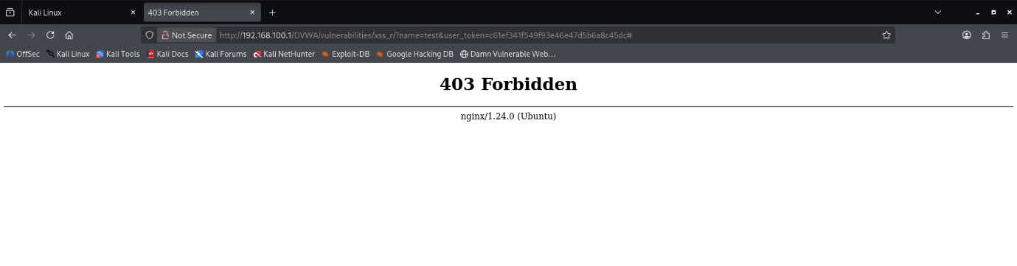

Figure 7.1: ModSecurity WAF blocked a malicious XSS request and returned an HTTP 403 Forbidden response to the attacker.
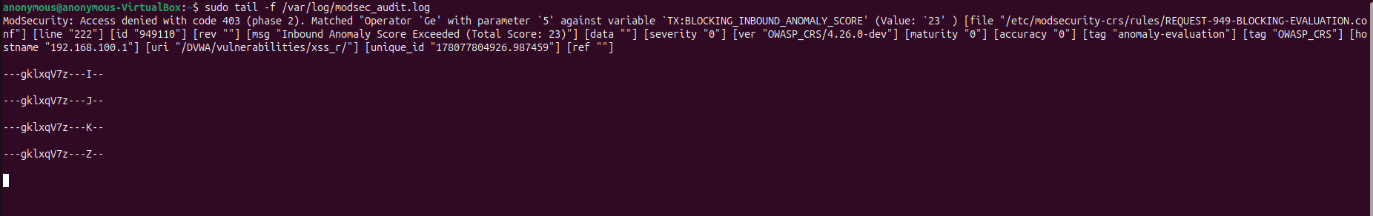

Figure 7.2: ModSecurity audit logs showing detection and blocking of a malicious XSS payload based on OWASP CRS rules.

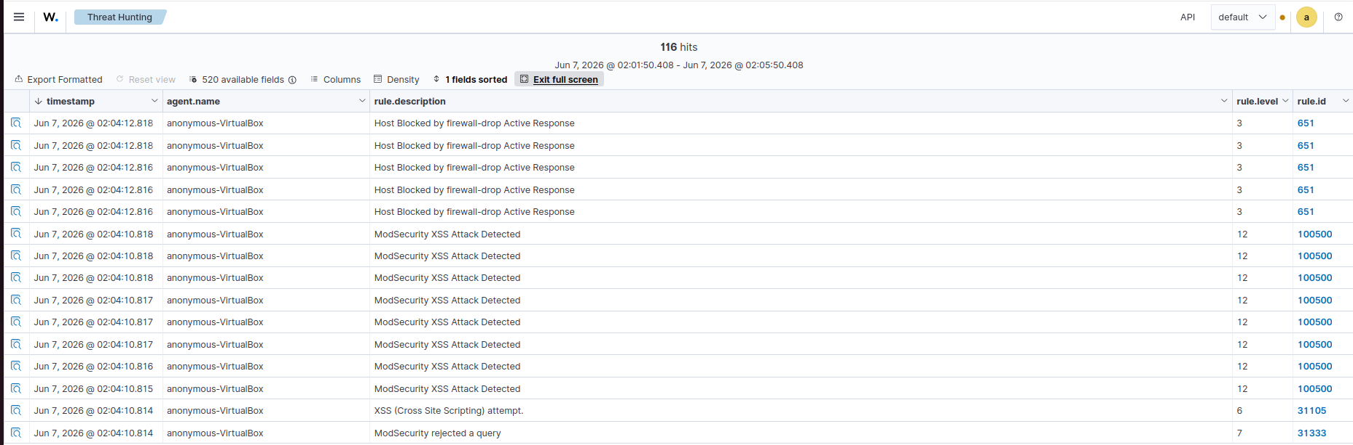
Figure 7.3: Wazuh SIEM generated security alerts for the detected XSS attack and triggered Active Response actions.

7.2 SQL Injection (SQLi)

SQL Injection is a technique used by attackers to manipulate backend database queries
through unsensitized user input. Successful exploitation may allow unauthorized access to sensitive information or modification of database contents.

Attack Scenario

The SQL Injection module within DVWA was used to simulate malicious database queries.

Sample Payload
‘ OR ‘1’=’1

Detection Process

- Malicious SQL input was submitted through DVWA.
- ModSecurity analyzed the request payload.
- OWASP CRS rules identified SQL Injection patterns.
- Security events were forwarded to Wazuh.
- Wazuh generated an alert and correlated the activity.

Results
SOCShield successfully detected the SQL Injection attempt and generated alerts containing attack information, source IP details, and security classifications.

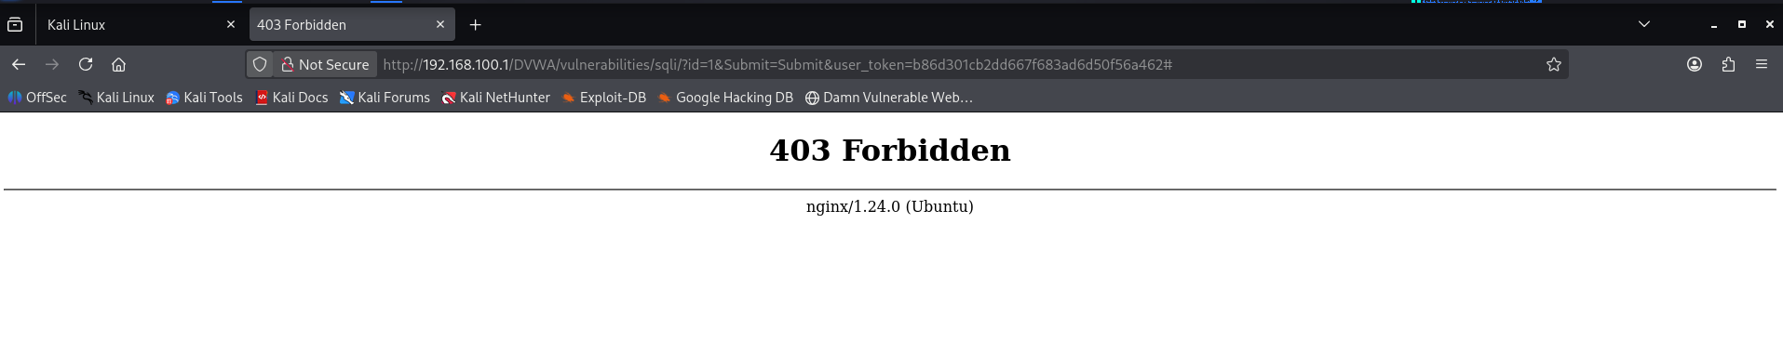
Figure 7.4: ModSecurity WAF blocked a malicious SQL Injection request and returned an HTTP 403 Forbidden response.

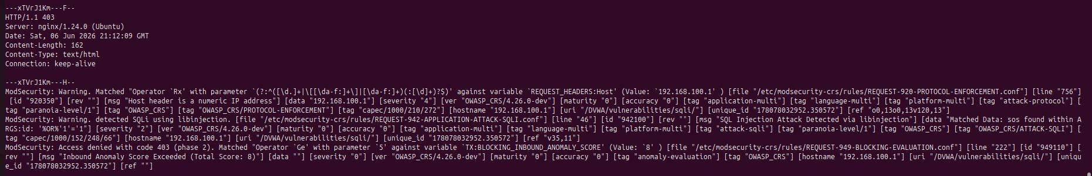

Figure 7.5: ModSecurity audit logs showing SQL Injection detection through OWASP CRS rules and anomaly score evaluation
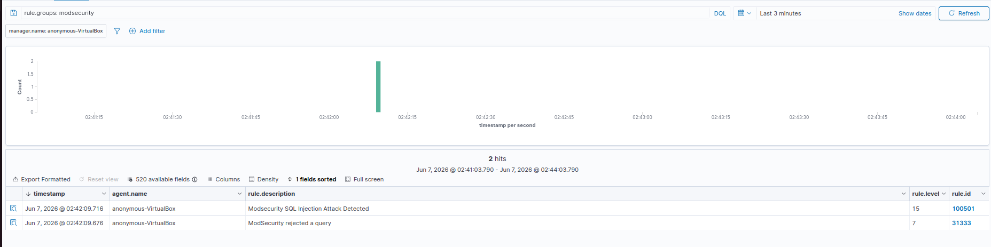
Figure 7.6: Wazuh SIEM generated security alerts for the detected SQL Injection attacks and correlated the event
for monitoring and investigation.

Attack Type: SQL Injection
Payload Example: ‘ OR ‘1’=’1
Detection Component: ModSecurity WAF
SIEM Detection: Wazuh Custom Rule (100501)
Severity: Level 15
Action Taken: Request blocked (HTTP 403)

SQL Injection Workflow

Attacker submits SQL Injection payload

NGNIX receives request

ModSecurity inspects payload

OWASP CRS identifies SQL Injection pattern

Request blocked with HTTP 403

Audit logs generated

Wazuh receives logs

Custom detection rule triggered

Alert displayed in Wazuh Dashboard

7.3 Remote Code Execution (RCE)

Remote Code Execution (RCE) attacks allow an attacker to execute arbitrary commands
on a target system. These attacks represent one of the highest-risk web application
vulnerabilities due to their potential impact.

Attack Scenario

The DVWA Command Execution module was used to simulate RCE attacks.

Sample payload
127.0.0.1 && whoami

Detection Process

- The malicious command was submitted through DVWA.
- ModSecurity detected suspicious command execution patterns.
- Custom Wazuh rules classified the event as an RCE attack.
- Security alerts were generated and mapped to MITRE ATT&CK techniques.
- Active Response mechanisms were triggered when configured conditions were met.

Results

The attack was successfully detected and classified as a Remote Code Execution attempt.
SOCShield generated alerts, MITRE ATT&CK mappings, and automated response actions
where applicable.

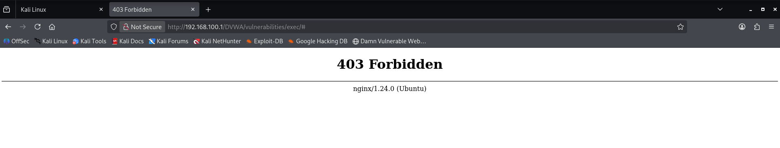
Figure 7.7: ModSecurity WAF blocked a Remote Code Execution (RCE) attempt and returned an HTTP 403 Forbidden response.

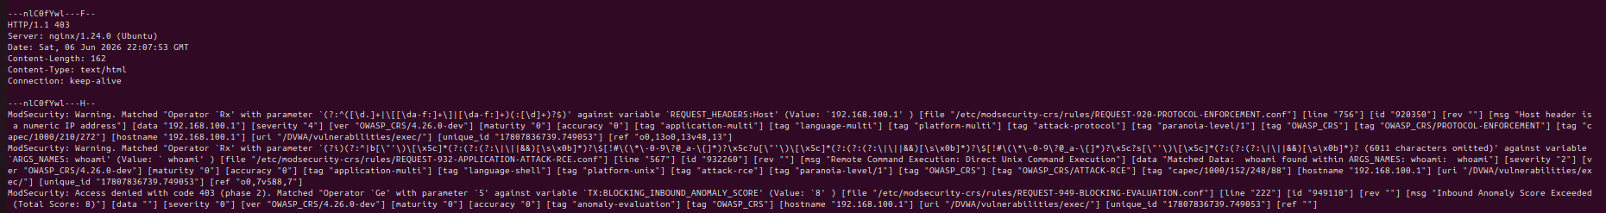

Figure 7.8: ModSecurity audit logs showing detection of a Remote Code Execution attempt through OWASP CRS RCE detection rules.
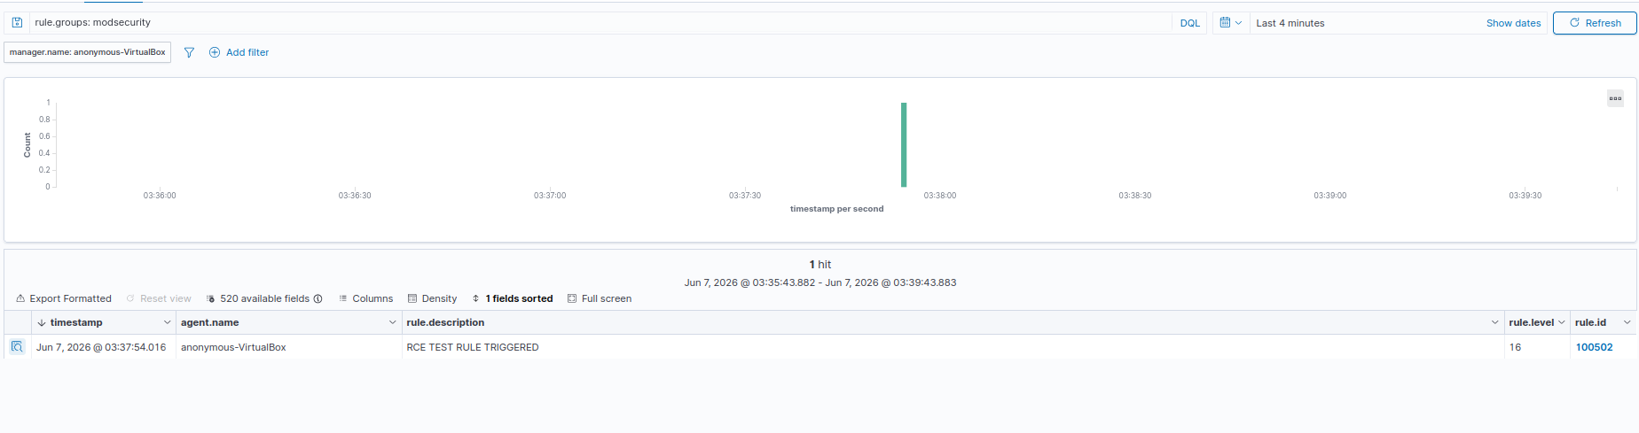

Figure 7.9: Wazuh SIEM generated a high-severity alert after receiving and processing the ModSecurity RCE detection event.

8. MITRE ATT&CK Mapping

8.1 Overview

The MITRE ATT&CK Framework is a globally recognized knowledge base of adversary tactics and techniques derived from real-world cyberattack observations. It provides a standardized method for classifying and understanding attacker behavior throughout the attack lifecycle.

SOCShield integrates MITRE ATT&CK mapping within the detection workflow to provide additional context for security analysts. By associating detected attacks with relevant ATT&CK techniques, analysts can better understand attacker objectives, improve threat hunting activities, and accelerate incident response.

The integration of MITRE ATT&CK mapping enhances the overall effectiveness of the Security Operations Center (SOC) by transforming raw security alerts into actionable threat intelligence.

8.2 MITRE ATT&CK Integration in SOCShield

When ModSecurity detects a malicious request and Wazuh generates a corresponding
alert, the event is enriched with MITRE ATT&CK tactics and techniques through custom
detection rules.
This process provides:
- Standardized attack classification
- Improved analyst visibility
- Enhanced incident investigation
- Threat hurting support
- Better understanding of adversary behavior

The mapped ATT&CK techniques are displayed directly within Wazuh alerts and dashboards.

8.3 Attack Mapping Examples

The following table illustrates the MITRE ATT&CK techniques associated with attacks detected during the SOCShield implementation.

Attack Type MITRE Technique ID Technique Name Tactic
Cross-Site Scrip- T1059 Command and Scripting Execution
ting (XSS) Interpreter

Remote Code T1059.004/ Command and Scripting Execution
Execution T1059 Interpreter

Directory Discovery T1083 File and Directory Discovery Discovery
Events

Web Application T1190 Exploit Public-Facing Initial
Attacks Application Access

8.4 MITRE ATT&CK Workflow

The attack classification workflow implemented in SOCShield is shown below:

Attack Detected
↓
ModSecurity Generates Security Event
↓
Wazuh Receives and Processes Log
↓
Custom Detection Rule Triggered
↓
MITRE ATT&CK Technique Assigned
↓
Alert Generated with ATT&CK Context
↓
Security Analyst Investigation

This workflow enables security analysts to quickly identify attacker objectives and understand the significance of security alerts.

8.5 Benefits of MITRE ATT&CK Mapping

The integration of MITRE ATT&CK within SOCShield provides several operational advantages:

Standardized Threat Classification
Security events are mapped to a globally recognized framework, ensuring consistent threat categorization.

Improved Threat Hunting
Analysts can search for ATT&CK techniques across historical security events and identify patterns of malicious activity.

Enhanced Incident Investigation
Mapped tactics and techniques provide additional context that assists analysts during incident response activities.

Security Monitoring Optimization
ATT&CK mappings help prioritize alerts based on attacker behavior and attack objectives.

SOC Maturity Improvement
The use of ATT&CK-based detections aligns SOCShield with modern Security Operations Center methodologies and industry best practices.

8.6 Results
The implementation successfully demonstrated the integration of MITRE ATT&CK mappings within the attack detection workflow. Security events generated from XSS, SQL Injection, Remote Code Execution, and discovery-related activities were enriched with ATT&CK context, providing analysts with improved visibility into adversary behavior and attack progression.
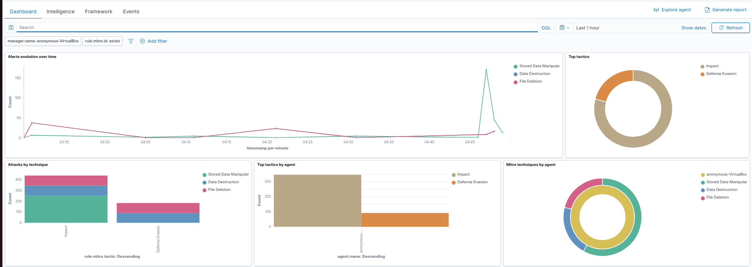

Figure 8.1: MITRE ATT&CK Dashboard displaying mapped tactics and techniques associated with monitored security events.
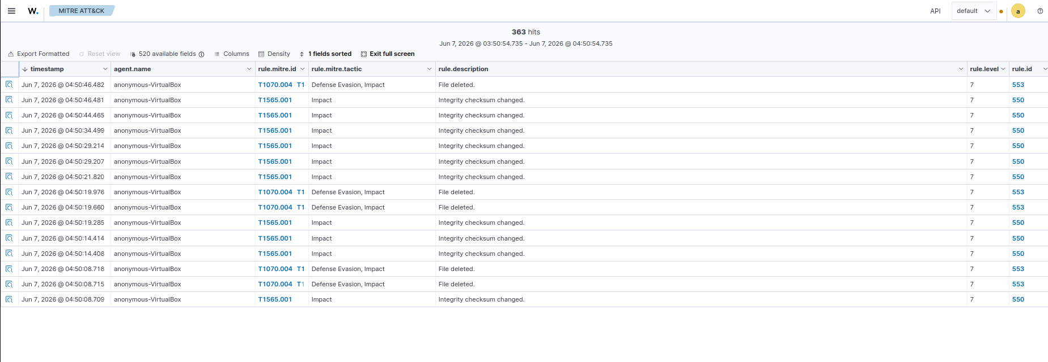
Figure 8.2: Individual security events enriched with MITRE ATT&CK technique and tactic information.

- SOCShield successfully leveraged the MITRE ATT&CK framework to enrich security events with adversary tactics and techniques. This enabled standardized threat classification, improved analyst visibility, and enhanced incident investigation capabilities.

9. Active Response

9.1 Overview

Detecting malicious activity is only the first step in the incident response lifecycle. To minimize the impact of security incidents, organizations must be capable of responding quickly to identified threats. Manual response processes often introduce delays that allow attackers additional time to continue malicious activities within the environment.

To address this challenge, SOCShield implements an automated Active Response mechanism using Wazuh's firewall-drop capability. When predefined security conditions are met, the platform automatically executes response actions to block malicious source IP addresses, reducing the attack surface and limiting further malicious activity.

The Active Response functionality enables SOCShield to transition from a passive monitoring platform to an intelligent security solution capable of taking immediate defensive actions against identified threats.

9.2 Active Response Architecture

The Active Response workflow consists of the following components:

- ModSecurity detects malicious web requests.
- Wazuh analyzes and correlates security events.
- Custom detection rules identify high-severity attacks.
- Active Response is triggered based on predefined rule conditions.
- The firewall-drop script is executed automatically.
- The malicious source IP address is blocked at the host firewall.
- An alert is generated and recorded within the Wazuh Dashboard.

The automated workflow significantly reduces the time required to contain malicious activity.
9.3 Active Response Configuration

Wazuh Active Response was configured using the built-in firewall-drop script. The response
Mechanism was linked to custom web attack detection rules developed for SOCShield.

The Active Response configuration was designed to:

- Identify malicious source IP addresses.
- Automatically block attacker systems.
- Generate response-related alerts.
- Log all response actions for auditing and investigation purposes.

The firewall-drop mechanism operates at the operating system level and dynamically updates firewall rules whenever a qualifying attack is detected.

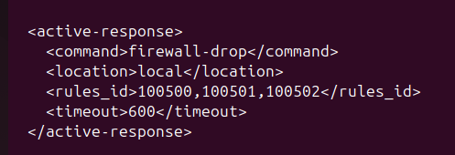

Figure 9.1 – Wazuh Active Response Configuration Using Firewall-Drop

Figure 9.1 illustrates the Active Response configuration implemented within Wazuh. When security events matching custom rule IDs 100500, 100501, and 100502 are detected, the firewall-drop response is automatically executed. The malicious source IP address is blocked locally for a period of 600 seconds, helping to contain potentially harmful activities and reduce the risk of repeated attack attempts.

9.4 Attack Response Workflow

The operational workflow implemented within SOCShield is shown below:

Attack Initiated

↓

ModSecurity Detects Malicious Request

↓

Wazuh Generates Security Alert

↓

Custom Rule Validation

↓

Active Response Triggered

↓

Firewall-Drop Executed

↓

Attacker IP Address Blocked

↓

Alert Logged and Displayed in Dashboard

9.5 Validation and Testing

To validate the Active Response capability, multiple attack scenarios were executed against the DVWA web application using Kali Linux and Burp Suite. High-severity attacks such as Remote Code Execution (RCE) were successfully detected by ModSecurity and forwarded to Wazuh for analysis.

Upon detection, the custom Wazuh rule triggered the firewall-drop Active Response action. The attacker source IP address was automatically added to the firewall block list, preventing additional requests from reaching the protected web application.

The generated alerts confirmed that the response action had been executed successfully and that the malicious IP address had been blocked.
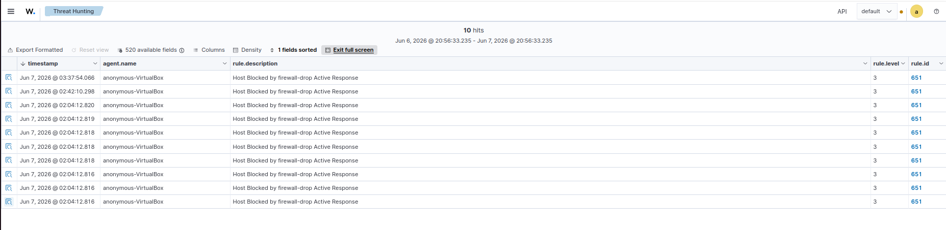
Figure 9.2 – Firewall-Drop Alert Generated by Wazuh
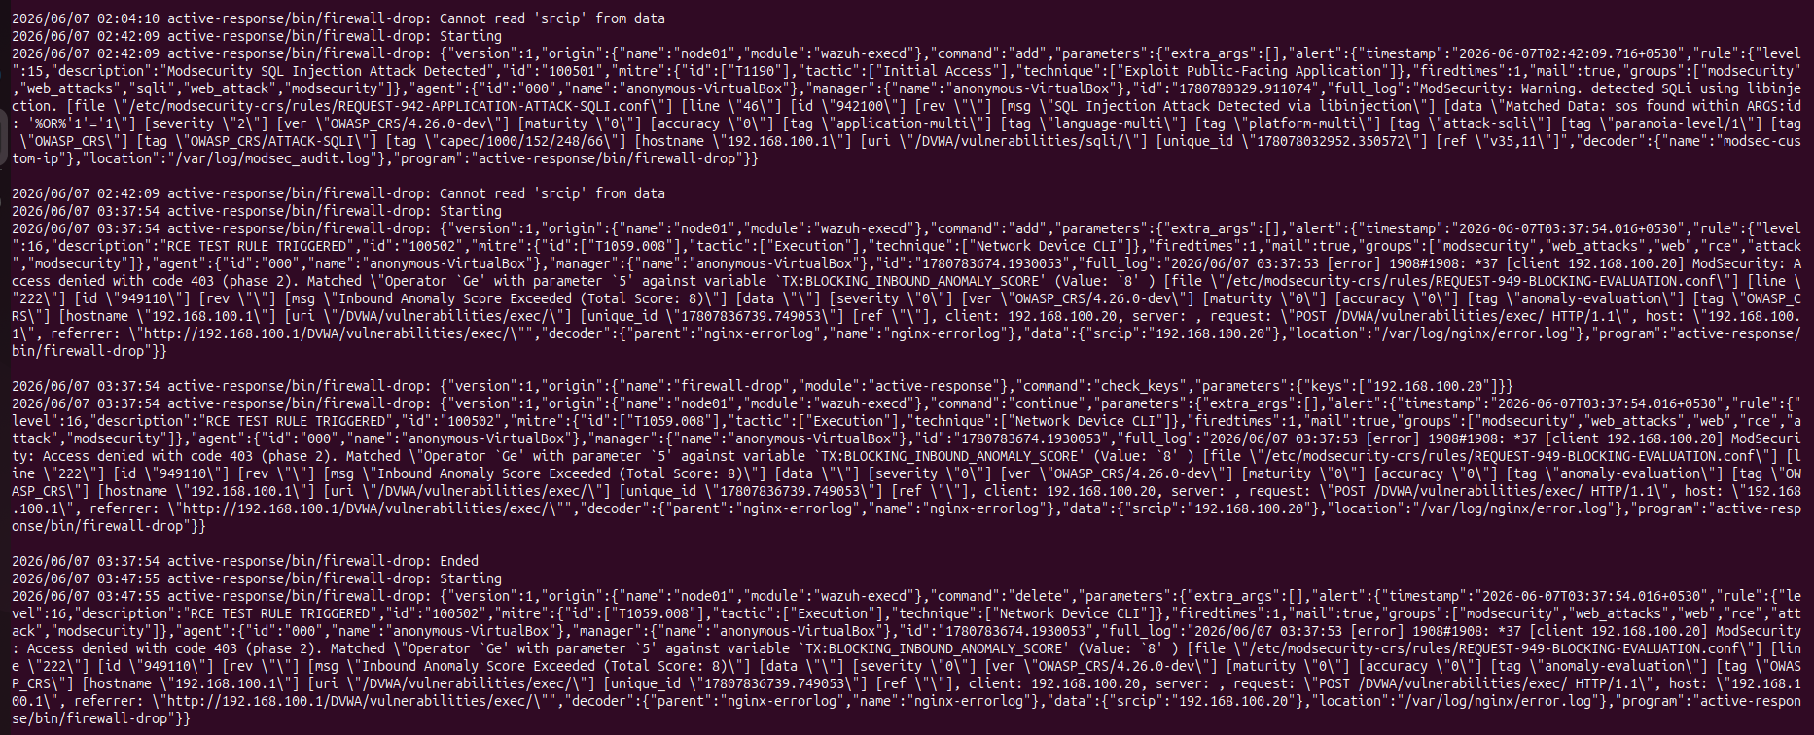

Figure 9.3 – Attacker Source IP Blocked Successfully

10. Threat Intelligence Integration

10.1 Overview

Threat Intelligence plays a critical role in modern Security Operations Center (SOCs) by providing contextual information about indicators of compromise (IOCs), malicious files, domains, URLs, and IP addresses. Integrating threat intelligence into the detection workflow helps security analysts make informed decisions and prioritize security incidents more effectively.

SOCShield integrates VirusTotal Threat Intelligence with Wazuh SIEM to enrich security alerts generated from web application attacks. VirusTotal aggregates threat intelligence from multiple security vendors and provides reputation information for suspicious files, domains, URLs, and IP addresses.

By incorporating VirusTotal into the detection workflow, SOCShield enhances alert visibility and enables analysts to quickly determine whether a detected indicator is known to be malicious, suspicious.

10.2 Integration Architecture

The VirusTotal integration was implemented using the native Wazuh Integration Module. Security events generated by Wazuh are forwarded to VirusTotal for reputation analysis and threat intelligence enrichment.

The integration workflow consists of the following steps:

- Wazuh detects a suspicious event.
- Relevant indicators are extracted from the alert.
- The VirusTotal integration module submits the indicators to VirusTotal.
- VirusTotal performs reputation analysis.
- Reputation results are returned to Wazuh.
- The enriched alert is displayed within the Wazuh Dashboard.

This process provides additional context for security analyst during threat investigations.
10.3 VirusTotal Configuration

VirusTotal integration was configured within the Wazuh Manager using the official VirusTotal API. The integration required the generation of an API key and modification of the Wazuh configuration file to enable communication with VirusTotal services.

The configuration included:

- VirusTotal API Key Configuration
- Wazuh Integration Module Setup
- Alert Enrichment Configuration
- Integration Validation and Testing

After successful configuration, Wazuh was capable of querying VirusTotal and incorporating
reputation information into generation alerts.

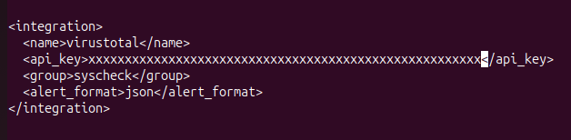

Figure 10.1 – VirusTotal Integration Configuration in Wazuh Manager

10.4 Threat Intelligence Enrichment Workflow

When a security event is generated, SOCShield attempts to enrich the event using VirusTotal reputation data. This enrichment process provides additional intelligence that assists analysts during investigations.

The enrichment workflow includes:

- Indicator extraction
- Reputation lookup
- Threat scoring
- Alert enhancement
- Analyst review

By combining local security telemetry with external threat intelligence sources, SOCShield improves overall situational awareness and accelerates incident response activities.

10.5 Validation and Testing

The VirusTotal integration was validated by generating security events and monitoring the resulting enrichment alerts within Wazuh. Multiple indicators were submitted for analysis to verify communication between Wazuh and VirusTotal.

Testing confirmed that the integration successfully communicated with the VirusTotal platform and generated enrichment-related events within the Wazuh Dashboard.

During testing, public API limitations were encountered due to request rate restrictions imposed by VirusTotal. These limitations were expected and demonstrated the operational constraints associated with public API usage.

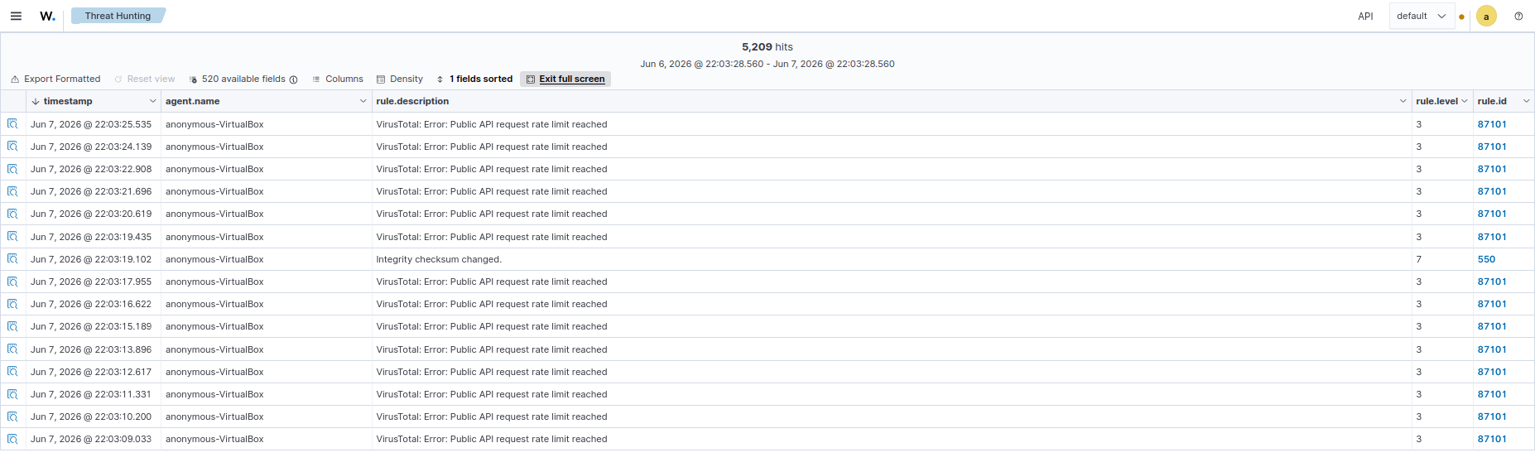

Figure 10.2 – VirusTotal API Rate Limitation Encountered During Testing

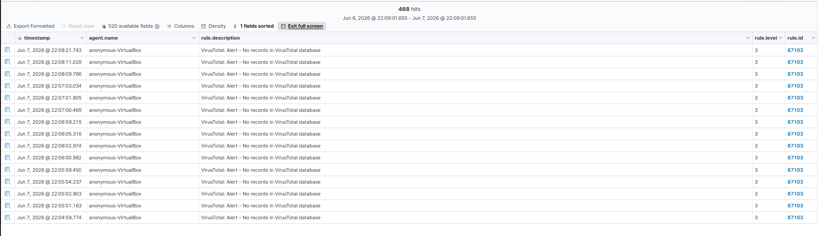

Figure 10.3 – VirusTotal Threat Intelligence Enrichment Result

10.6 Benefits of Threat Intelligence Integration

The integration of VirusTotal within SOCShield provides several operational benefits:

- Enhanced threat visibility
- Reputation-based analysis
- Improved incident investigation
- Faster analyst decision-making
- External threat intelligence enrichment
- Better threat prioritization

Threat intelligence enrichment allows analysts to correlate internal security events with external intelligence sources, improving the overall effectiveness of the Security Operations Center.

11. Email Alerting

11.1 Overview

Timely notification of security incidents is essential for effective incident response. While dashboards provide centralized visibility into security events, analysts may not continuously monitor the Security Operations Center (SOC) console. As a result, critical alerts can be overlooked or delayed.

To address this challenge, SOCShield implements a real-time email alerting mechanism using Wazuh, Postfix Mail Transfer Agent (MTA), and Gmail SMTP services. The alerting system automatically notifies security analysts whenever predefined security events are detected, ensuring rapid awareness and response to potential threats.

The email alerting capability enhances the effectiveness of SOCShield by providing immediate notification of security incidents without requiring constant dashboard monitoring.

11.2 Email Alerting Architecture

The email notification workflow consists of the following components:

- ModSecurity detects a malicious web request.
- Wazuh generates a security alert.
- Alert severity and rule conditions are evaluated.
- Wazuh forwards the alert to Postfix.
- Postfix relays the email through Gmail SMTP
- The security analyst receives a notification email.

This workflow ensures that important security events are communicated to analysts as soon as they occur.

11.3 Email Alert Configuration

Email alerting was configured within the Wazuh Manager using Postfix as the Mail Transfer Agent (MTA). Gmail SMTP services were used to relay outgoing email notifications.

The configuration process included:

- Postfix installation and configuration
- Gmail SMTP integration
- Authentication using App Passwords
- Wazuh email notification configuration
- Alert delivery validation and testing

After successful configuration, Wazuh was capable of automatically generating and sending email notifications for security events.

11.4 Alert Notification Workflow

The operational workflow implemented within SOCShield is shown below:

Attack Detected
↓
Wazuh Generates Alert
↓
Alert Severity Evaluated
↓
Postfix Processes Email
↓
Gmail SMTP Relays Message
↓
Security Analyst Receives Notification

This automated process reduces the time required for analysts to become aware of security incidents.

11.5 Validation and Testing

The email alerting functionality was validated by generating security events through simulated attack scenarios against the DVWA web application.

Multiple attacks, including Cross-Site Scripting (XSS), SQL Injection (SQLi), and Remote Code Execution (RCE), were executed to verify alert generation and email delivery functionality.

Testing confirmed that security alerts generated within Wazuh were successfully processed by Postfix and delivered through Gmail SMTP. Notification emails were received by the designated analyst mailbox, demonstrating successful end-to-end alert delivery.

The testing process also included troubleshooting SMTP authentication and Gmail application password configuration to ensure reliable email transmission.

11.6 Benefits of Email Alerting

The implementation of email alerting within SOCShield provides several operational advantages:
- Immediate analyst notification
- Faster incident response
- Improved threat visibility
- Reduced dependency on dashboard monitoring
- Automated alert delivery
- Enhanced security operations efficiency

By integrating automated email notifications into the SOC workflow, SOCShield improves analyst awareness and supports timely response to security incidents.

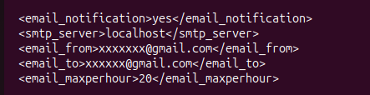

Figure 11.1 – Wazuh Email Notification Configuration

Figure 11.1 shows the email notification configuration implemented within the Wazuh Manager. Email alerting was enabled by configuring the SMTP server, sender address, recipient address, and notification limits. This configuration allows Wazuh to automatically generate and forward security alerts to the designated analyst mailbox.

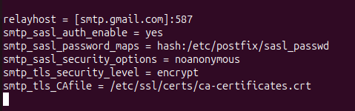

Figure 11.2 – Postfix Gmail SMTP Relay Configuration

Figure 11.2 shows the Postfix SMTP relay configuration used within SOCShield. Postfix was configured to authenticate with Gmail SMTP services using TLS encryption and application-password-based authentication, enabling secure delivery of security alert notifications generated by Wazuh.

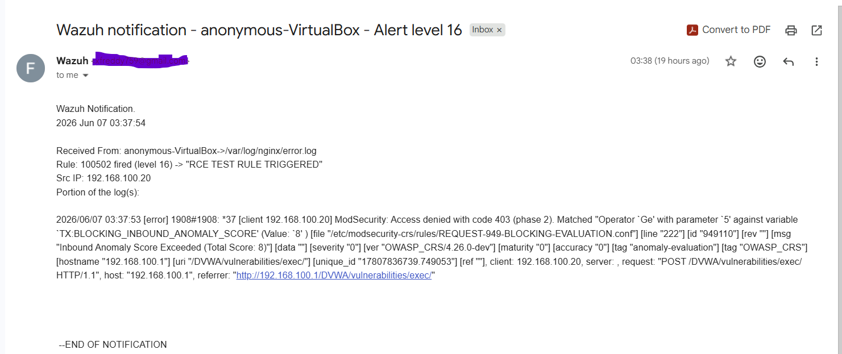

Figure 11.3 – Security Alert Email Received by Analyst Following Detection of a Remote Code Execution (RCE) Attack

12. Dashboard & Monitoring

12.1 Overview
Modern Security Operations Centers (SOCs) rely heavily on dashboards to provide real-time visibility into security events, threat trends, and incident response activities. Effective dashboards enable analysts to quickly identify suspicious activities, prioritize investigations, and monitor security operations from a centralized interface.
SOCShield incorporates multiple custom dashboards within Wazuh to visualize web attack activity, monitor active response actions, analyze attacker behavior, and support threat hunting operations. These dashboards transform raw security events into actionable intelligence, improving situational awareness and accelerating incident response

12.2 Web Attack Monitoring Dashboard
The Web Attack Monitoring Dashboard was developed to provide a consolidated view of web application attacks detected by ModSecurity and analysed by Wazuh.
The dashboard includes:
- Attack Timeline Visualization
- Attack Type Distribution
- Severity Distribution Analysis
- Web Attack Event Table

The dashboard enables security analysts to monitor attack trends and identify the most frequently occurring attack types within the protected environment.

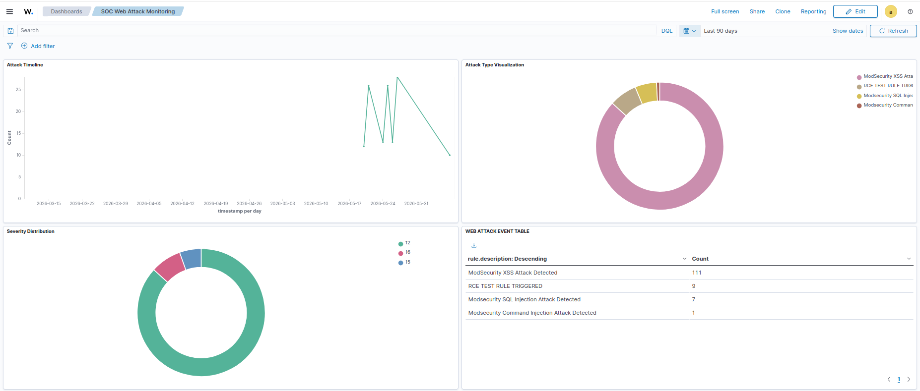
Figure 12.1 – SOC Web Attack Monitoring Dashboard
Figure 12.1 presents the SOC Web Attack Monitoring Dashboard developed within SOCShield. The dashboard provides real-time visibility into web application attacks detected by ModSecurity and analyzed by Wazuh. It includes attack timelines, attack type distribution, severity distribution, and a summarized event table. During testing, the dashboard successfully identified Cross-Site Scripting (XSS), SQL Injection (SQLi), Remote Code Execution (RCE), and Command Injection attacks.
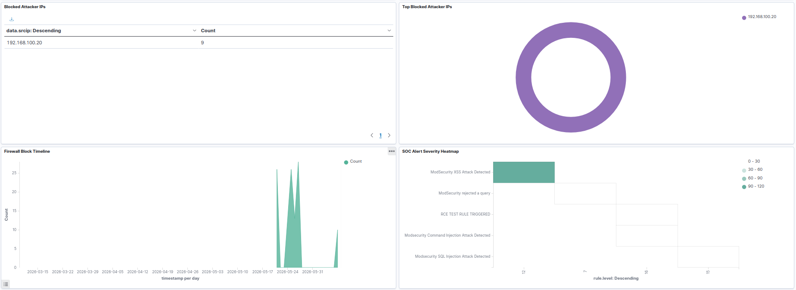
Figure 12.2 – Active Response Monitoring Dashboard

Figure 12.2 illustrates the Active Response Monitoring Dashboard. The dashboard provides visibility into blocked attacker IP addresses, firewall-drop activity, and response timelines. It confirms the successful execution of Wazuh Active Response actions and demonstrates automated containment of malicious activity by blocking attacker IP addresses following high-severity security events.

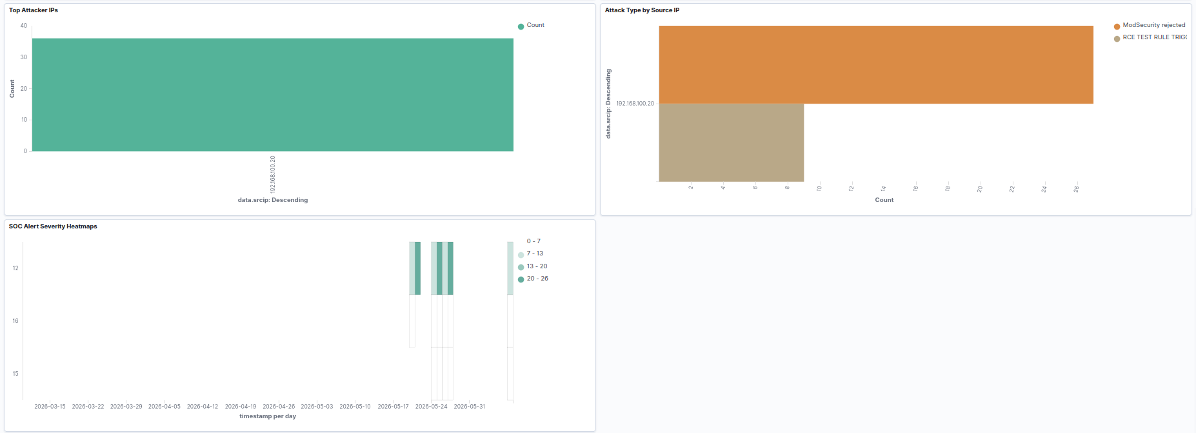
Figure 12.3 – Threat Analysis Dashboard

Figure 12.3 presents the Threat Analysis Dashboard developed within SOCShield. The dashboard correlates attacker source IP addresses with detected attack types and severity levels. By visualizing attack attribution and threat distribution, analysts can quickly identify malicious sources, investigate attack behavior, and prioritize incident response activities.

13. Results

13.1 Overview

The SOCShield platform was successfully implemented and tested in a controlled laboratory environment. Multiple web application attack scenarios were executed against the DVWA application to validate the detection, monitoring, threat intelligence, alerting, and automated response capabilities of the platform.
The project successfully demonstrated the integration of ModSecurity Web Application Firewall, Wazuh SIEM, VirusTotal Threat Intelligence, Email Alerting, MITRE ATT&CK Mapping, and Active Response mechanisms within a unified Security Operations Center (SOC) monitoring environment.
Testing confirmed that SOCShield was capable of detecting malicious activities, enriching alerts with threat intelligence, notifying analysts through email, and automatically responding to selected high-severity attacks.

13.2 Attack Detection Results

SOCShield successfully detected multiple web application attack types generated during testing. Custom Wazuh rules and ModSecurity signatures were used to identify malicious requests and generate security alerts.

The platform successfully detected:
- “Cross-Site Scripting (XSS)”
- “SQL Injection (SQLi)”
- “Remote Code Execution (RCE)”
- “Command Injection Attempts”

Attack events were recorded within the Wazuh dashboard and visualized through custom monitoring dashboards.

- Attack Detection Results

Attack Type Detection Status
- XSS Successfully Detected
- SQL Injection Successfully Detected
- RCE Successfully Detected
- Command Injection Successfully Detected

13.3 MITRE ATT&CK Mapping Results

SOCShield successfully mapped detected attacks to relevant MITRE ATT&CK tactics and techniques. This provided additional context to analysts and improved understanding of attacker behaviour.
The mapping process enabled classification of attack activities according to industry-recognized threat intelligence standards.

- Table – MITRE ATT&CK Mapping Results

Attack MITRE Technique
- SQL Injection Exploit Public-Facing Application (T1190)
- RCE Command and Scripting Interpreter (T1059)
- Web Attacks Initial Access Techniques

13.4 Active Response Results

Active Response testing confirmed that Wazuh successfully executed the firewall-drop mechanism upon detection of high-severity attack events. Malicious source IP addresses were automatically blocked, reducing the potential impact of repeated attack attempts.
Response actions were logged within the Wazuh platform and visualized through the Active Response Dashboard.

- Table – Active Response Results

Feature Status
- Firewall-Drop Execution Successful
- IP Blocking Successful
- Response Logging Successful
- Dashboard Visualization Successful

13.5 Threat Intelligence Results
VirusTotal Threat Intelligence integration was successfully configured and validated. Security indicators were submitted for reputation analysis and enrichment within Wazuh.
During testing, VirusTotal enrichment alerts were generated successfully. Public API rate limitations were observed during high-frequency testing, demonstrating expected operational constraints associated with the public VirusTotal API tier.

- Table – Threat Intelligence Results

Capability Status
- VirusTotal Integration Successful
- Threat Enrichment Successful
- Reputation Lookup Successful
- API Communication Successful

13.6 Email Alerting Results
Email alerting functionality was successfully implemented using Postfix and Gmail SMTP services. Security alerts generated by Wazuh were automatically delivered to the analyst mailbox.
Testing confirmed end-to-end notification delivery for detected security events, improving analyst awareness and reducing incident response delays.

- Table – Email Alerting Results

Feature Status
- Email Notification Successful
- SMTP Relay Successful
- Alert Delivery Successful
- Analyst Notification Successful

13.7 Dashboard and Monitoring Results

Multiple custom dashboards were developed to provide centralized visibility into attack activity, attacker behaviour, security event severity, and automated response actions.
The dashboards successfully visualized:
- “Attack timelines”
- “Attack type distribution”
- “Severity analysis”
- “Attacker source IP analysis”
- “Firewall block activity”
- “Active Response execution”

13.8 Overall Project Outcome

The implementation of SOCShield successfully achieved all project objectives. The platform demonstrated the ability to detect web application attacks, enrich alerts with threat intelligence, automate incident response actions, notify analysts through email, and provide comprehensive monitoring through custom dashboards.
The project validates the effectiveness of combining Web Application Firewalls, SIEM technologies, threat intelligence feeds, and automated response mechanisms to create a practical Security Operations Center solution for modern cybersecurity environments.

14. Challenges Encountered

14.1 Overview

The development of SOCShield involved the integration of multiple cybersecurity technologies including Wazuh SIEM, ModSecurity WAF, NGINX, DVWA, VirusTotal, Postfix, and custom dashboards. Due to the complexity of integrating multiple security components within a single environment, several technical and operational challenges were encountered throughout the project lifecycle.
These challenges ranged from system deployment and networking issues to log parsing, alert correlation, threat intelligence integration, automated response execution, and dashboard development. Resolving these issues required extensive troubleshooting, testing, and configuration refinement.

14.2 Virtual Environment and Network Configuration Challenges

Challenge
- VM-to-VM connectivity problems
- Incorrect network adapter configurations
- IP addressing conflicts
- NAT and Host-Only network troubleshooting
- Service accessibility issues between systems

Resolution
Network interfaces were reconfigured and connectivity was validated using tools such as ping, netstat, ss, and tcpdump. Static IP addressing was implemented to ensure stable communication between project components.

Outcome
Reliable communication was established across all systems, enabling attack simulation and centralized monitoring.

14.3 Wazuh Installation and Service Configuration Challenges

Challenge

During the deployment of Wazuh Manager and associated services, several service initialization and configuration issues were encountered. Some components failed to start correctly due to dependency and configuration inconsistencies.

Resolution

Service logs were analyzed using journalctl and Wazuh log files. Configuration errors were corrected and services were restarted and validated after each modification.

Outcome

Wazuh Manager and supporting services operated successfully and provided centralized security monitoring.

14.4 ModSecurity and Log Collection Challenges

Challenge
Although ModSecurity successfully detected malicious requests, ensuring that logs were correctly collected and processed by Wazuh required additional configuration.

Issues included:
- Incorrect log file paths
- Missing log collection configuration
- Event parsing inconsistencies
- Incomplete attack details in generated alerts

Resolution
Log collection settings were refined and custom decoders were implemented to improve event parsing and extraction of attack-related information.

Outcome
ModSecurity events were successfully forwarded to Wazuh for analysis and correlation.
14.5 Custom Rule Development Challenges

Challenge
Default Wazuh rules did not provide the desired level of attack categorization required for SOCShield. Specific detection requirements for XSS, SQL Injection, RCE, and Command Injection attacks required the development of custom rules.

Resolution
Custom rule IDs, severity levels, and alert descriptions were created and tested using multiple attack scenarios.

Outcome
The platform successfully generated attack-specific alerts with improved visibility and classification.

14.6 Active Response Source IP Extraction Challenges

Challenge
During Active Response implementation, the firewall-drop mechanism initially failed because the source IP address could not be extracted from generated alerts.

Observed error:
active-response/bin/firewall-drop:
Cannot read 'srcip' from data

Resolution
Alert structures, decoders, and rule mappings were modified to ensure correct extraction of attacker IP addresses.

Outcome
Active Response successfully executed firewall-drop actions and blocked malicious source IP addresses.

14.7 VirusTotal Threat Intelligence Integration Challenges

Challenge
Integrating VirusTotal with Wazuh required API configuration and validation. During testing, public API limitations resulted in rate-limit errors when multiple requests were generated within a short period.

Observed alert:
VirusTotal:
Error: Public API request rate limit reached

Resolution
Request frequency was adjusted and testing procedures were modified to remain within VirusTotal public API limitations.

Outcome
Threat intelligence enrichment functionality was successfully validated.

14.8 Email Alerting Challenges

Challenge
Initial attempts to send security notifications failed due to SMTP configuration issues and Gmail authentication restrictions.

Issues included:
- Incorrect SMTP settings
- Authentication failures
- Mail delivery errors
- Gmail security restrictions

Resolution
Postfix was configured as the SMTP relay service and Gmail App Password authentication was implemented.

Outcome: Security alerts were successfully delivered to the analyst mailbox.
14.9 Dashboard Development Challenges

Challenge
Building meaningful SOC dashboards required extensive experimentation with Wazuh visualization tools and field mappings.

Challenges included:
- Selecting relevant data fields
- Creating attack correlation views
- Designing severity heatmaps
- Visualizing attacker IP activity
- Developing response monitoring dashboards

Resolution
Multiple dashboard iterations were created and refined until useful operational visualizations were achieved.

Outcome
Custom SOC dashboards successfully visualized attack activity, threat trends, and response actions.

14.10 Integration and Correlation Challenges

Challenge
SOCShield combines several independent technologies that were not originally designed to work together as a single platform.

Integrated components included:
- Kali Linux
- Burp Suite
- DVWA
- NGINX
- ModSecurity
- Wazuh
- VirusTotal
- Postfix

Ensuring consistent data flow between these components required extensive troubleshooting.

Resolution
Log collection paths, rule mappings, integrations, and communication settings were repeatedly validated and adjusted.

Outcome
Successful end-to-end event correlation was achieved.

14.11 Testing and Validation Challenges

Challenge
Validating every security capability required generating realistic attack scenarios without disrupting the environment.

Challenges included:
- Reproducing attack events consistently
- Triggering specific detection rules
- Validating Active Response execution
- Testing threat intelligence enrichment
- Confirming email delivery

Resolution
Controlled attack simulations using DVWA and Burp Suite were repeatedly executed and monitored through Wazuh.

Outcome
All major platform features were successfully tested and validated.

15. Future Enhancements

15.1 Overview
Although SOCShield successfully demonstrates web attack detection, threat intelligence enrichment, automated response, and security monitoring capabilities, several enhancements can be implemented in future versions to improve scalability, intelligence, automation, and enterprise readiness.
The following enhancements represent potential improvements that would further strengthen the platform and expand its capabilities within modern Security Operations Center (SOC) environments.

15.2 Multi-Agent Deployment

Proposed Enhancement
The current implementation primarily focuses on monitoring a single web application environment. Future versions of SOCShield can support multiple Wazuh agents deployed across various servers, endpoints, and network devices.

Benefits
- Centralized monitoring of multiple assets
- Improved enterprise visibility
- Enhanced threat detection coverage
- Scalable architecture

15.3 Integration with Additional Threat Intelligence Sources

Proposed Enhancement
Currently, VirusTotal is used for threat intelligence enrichment. Future implementations can integrate multiple threat intelligence feeds to provide broader context and improved indicator reputation analysis.

Potential Integrations
- AbuseIPDB
- AlienVault OTX
- MISP
- URLHaus
- OpenPhish

Benefits
- Improved threat intelligence coverage
- Better indicator correlation
- Enhanced threat hunting capabilities

15.4 SOAR Integration

Proposed Enhancement
Future versions of SOCShield can integrate Security Orchestration, Automation, and Response (SOAR) platforms to automate incident investigation and response workflows.

Possible Platforms
- Shuffle SOAR
- TheHive
- Cortex
- Splunk SOAR

Benefits
- Automated playbooks
- Faster incident response
- Reduced analyst workload
- Improved operational efficiency

15.5 Advanced Active Response Mechanisms

Proposed Enhancement
The current implementation uses firewall-drop actions to block malicious source IP addresses. Future versions can implement more advanced response actions.

Possible Actions
- Dynamic firewall updates
- User account isolation
- Automated quarantine
- Endpoint containment
- Web server rule updates

Benefits
- Stronger threat containment
- Reduced attacker dwell time Improved response effectiveness

16. Conclusion

The increasing frequency and sophistication of web-based cyber-attacks have made continuous monitoring, threat detection, and rapid incident response essential requirements for modern organizations. Traditional security monitoring approaches often struggle to provide the visibility, intelligence, and automation necessary to effectively identify and respond to emerging threats.

SOCShield was developed as an intelligent Security Operations Center (SOC) platform designed to address these challenges through the integration of open-source security technologies. The project successfully combined Wazuh SIEM, ModSecurity Web Application Firewall (WAF), NGINX, DVWA, VirusTotal Threat Intelligence, MITRE ATT&CK Mapping, Active Response mechanisms, Email Alerting, and custom security dashboards into a unified monitoring and response environment.

Throughout the project, multiple web application attack scenarios including Cross-Site Scripting (XSS), SQL Injection (SQLi), Remote Code Execution (RCE), and Command Injection were successfully simulated and detected. Security events generated by these attacks were collected, analyzed, correlated, and visualized through centralized dashboards, providing valuable insights into attacker behavior and security posture.

The implementation of VirusTotal integration enhanced threat visibility through reputation-based threat intelligence enrichment, while MITRE ATT&CK Mapping provided standardized classification of attack techniques and tactics. In addition, automated Active Response capabilities demonstrated the ability to contain malicious activity by dynamically blocking attacker IP addresses through firewall-drop actions. Real-time email notifications further improved analyst awareness by ensuring immediate delivery of critical security alerts.

The custom dashboards developed within SOCShield successfully transformed raw security logs into actionable intelligence by providing visibility into attack trends, severity distributions, attacker source analysis, and automated response activities. These visualizations improved monitoring efficiency and supported effective threat hunting and incident investigation.

The successful completion of SOCShield demonstrates that a practical and effective Security Operations Center can be built using open-source technologies while maintaining strong detection, monitoring, threat intelligence, and response capabilities. The project provided valuable hands-on experience in SIEM deployment, web application security monitoring, threat intelligence integration, automated response implementation, dashboard development, and SOC operations.

In conclusion, SOCShield successfully achieved all defined project objectives and demonstrated a comprehensive approach to modern web application threat detection, analysis, and response. The platform serves as a practical example of how integrated security technologies can be leveraged to enhance organizational cybersecurity capabilities and strengthen overall security operations.

